Chapter 12, Solution 56.

Using Fig. 12.63, design a problem to help other students to better understand unbalanced three-phase systems.

Although there are many ways to solve this problem, this is an example based on the same kind of problem asked in the third edition.

Problem

Refer to the unbalanced circuit of Fig. 12.63. Calculate:

(a) the line currents

(b) the real power absorbed by the load

(c) the total complex power supplied by the source

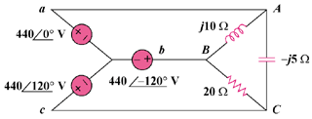

Figure 12.63

Solution

- Consider the circuit below.
j10 
20 
-j5 
I₃
A
C
B
−
+
4400
440120
440-120
−
+
−
+
a
b
c
I₁
I₂

For mesh 1,
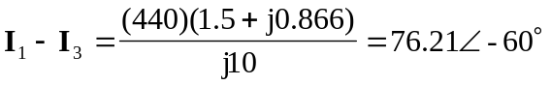 (1)

For mesh 2,
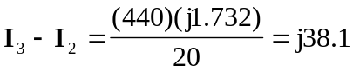 (2)
For mesh 3,
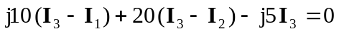

Substituting (1) and (2) into the equation for mesh 3 gives,
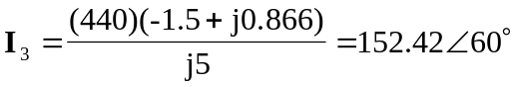 (3)

From (1),

From (2),

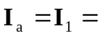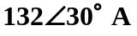

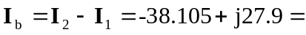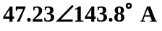

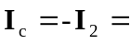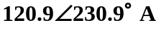

- 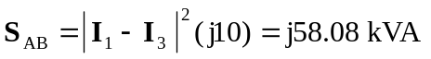
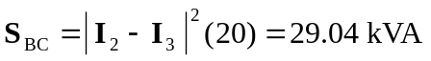

Real power absorbed = 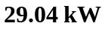

- Total complex supplied by the source is
